# CS 255 System Design Document Template

## UML Diagrams

### UML Use Case Diagram

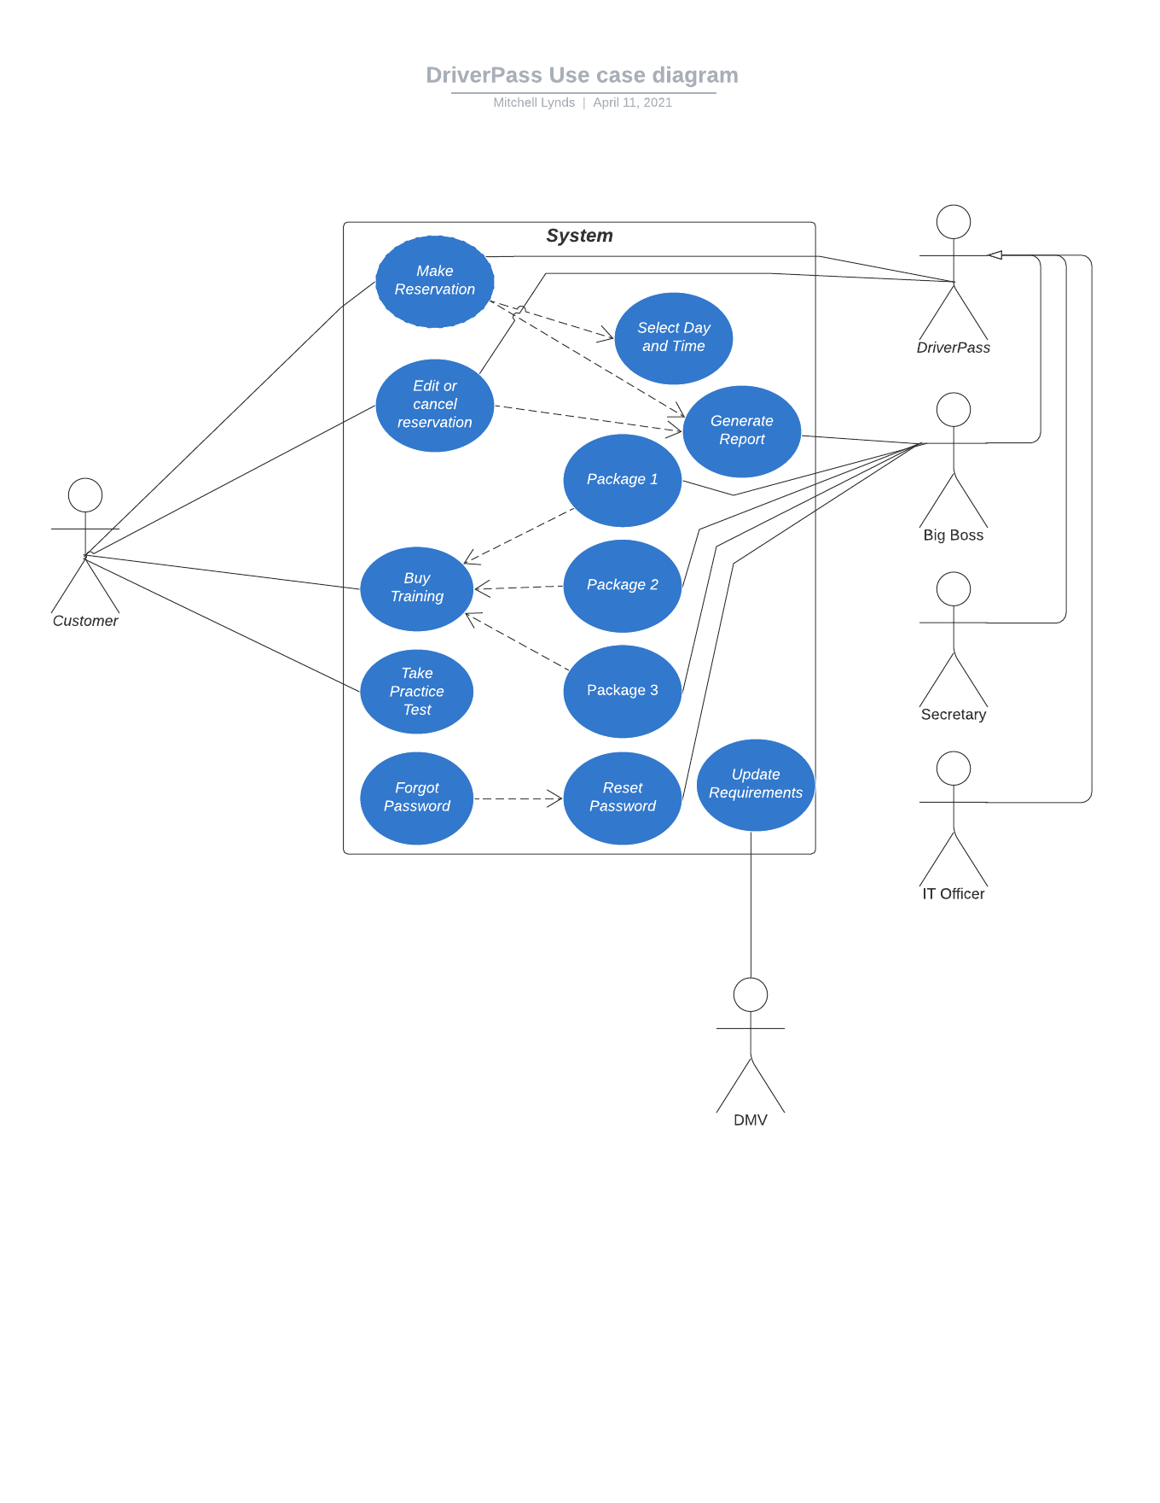

### UML Activity Diagrams

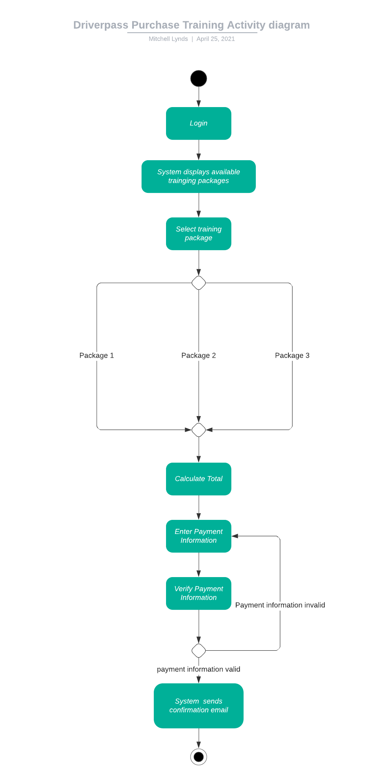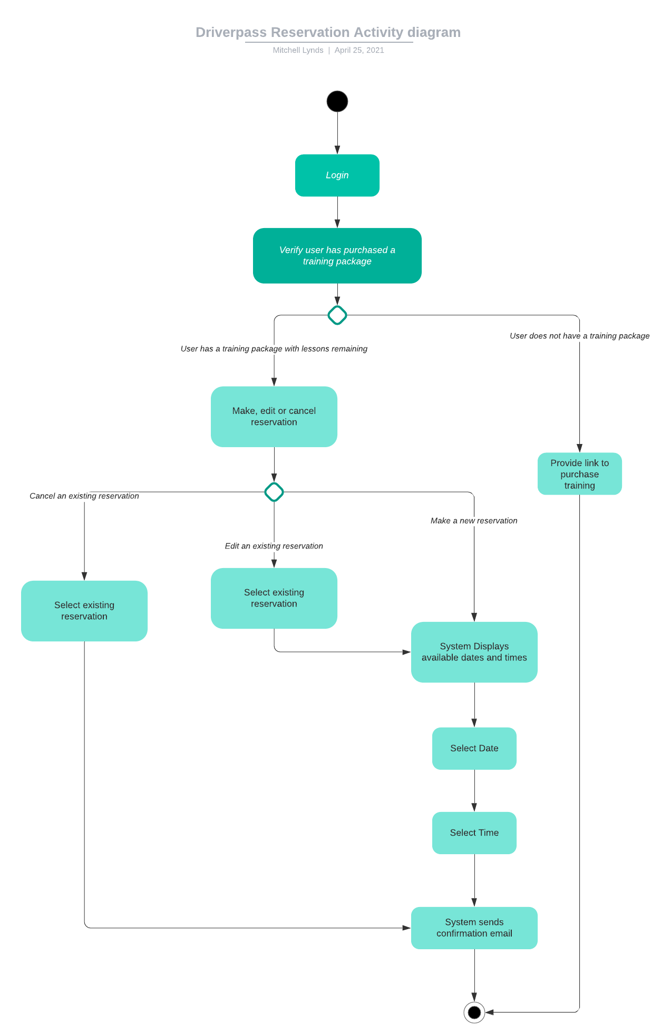

### UML Sequence Diagram

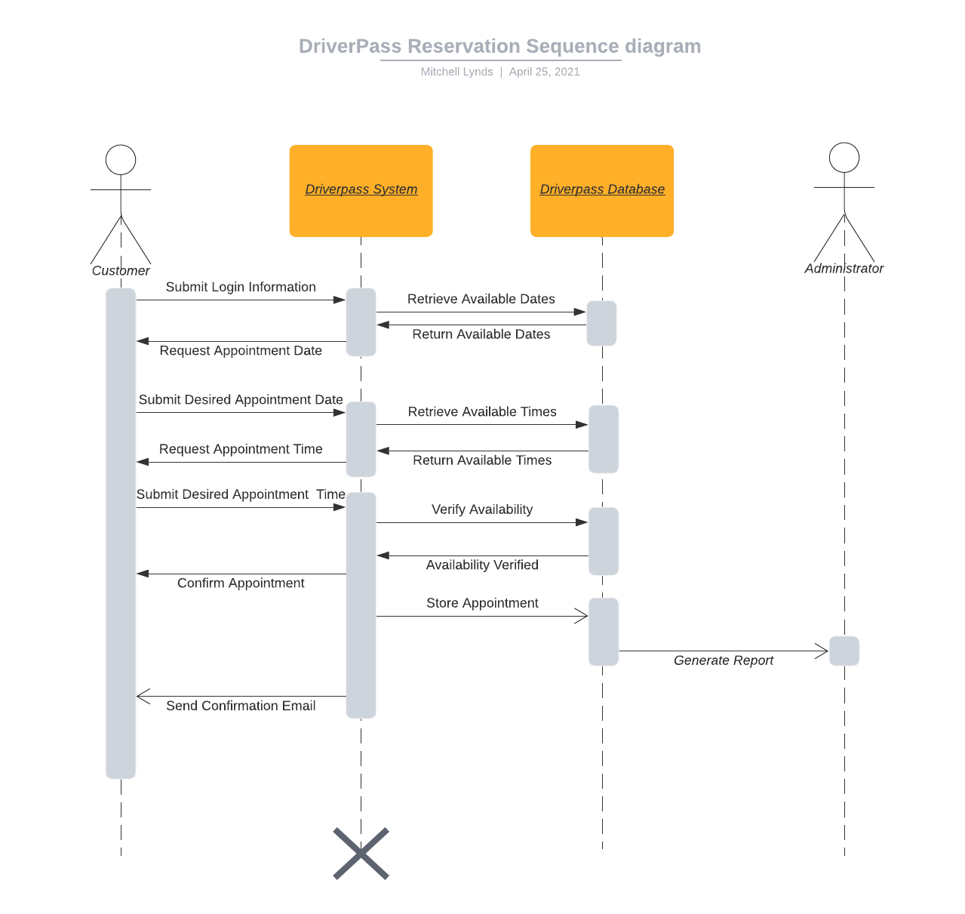

### UML Class Diagram

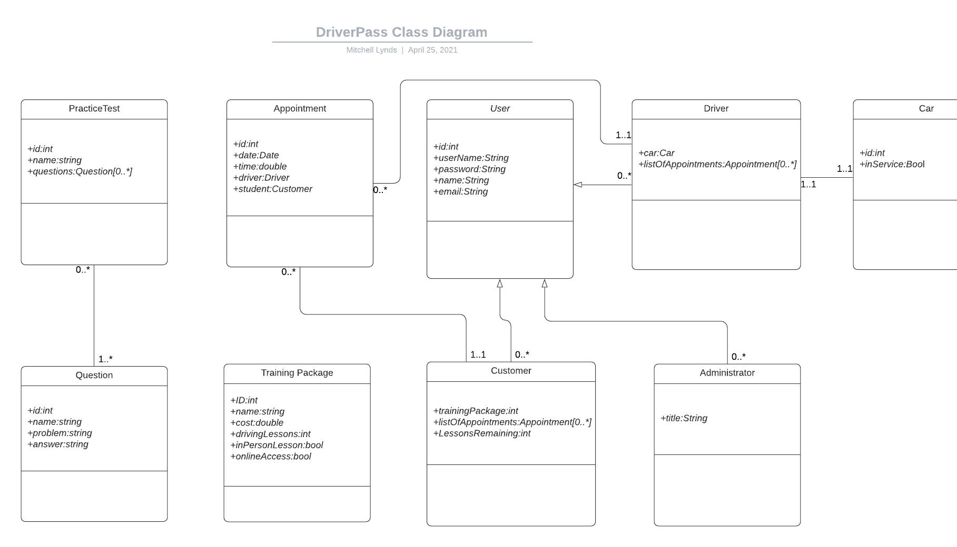

## Technical Requirements

* Since the DriverPass system will be a web-based application and cloud-hosted there will be no hardware requirements for DriverPass except that the cloud host will need to dedicate enough storage for the DriverPass database. The database will store all user information, test questions, and appointments. Because all of these storage items are text based the storage requirements of the database will be unlikely to exceed 1-2 Gb. If in the future the practice tests and online lessons expand to include video lessons and video based questions the host may need to increase this storage to the scale of a few hundred Gb.
* For software requirements DriverPass employees will require a web-browser application. The DriverPass system will be compatible with all major web-browsers.
* On the infrastructure side DriverPass employees and customers will need reliable internet access. Internet speed should not be a concern because all of the currently planned features of the DriverPass system do not involve video or large numbers of images.